16TH MEMBERS AND FAMILY FUN DAY
EVENT HANDBOOK

Index

Part A: Age groups ……………………………………………… P.2

Part B: Track and Field Competitions ……………………….. P.3 - 6

Part C: Drawing Competition ………………………………… P. 7

Part D: Talent Show ………………………………………….. P. 8

Part E: Registration ………………………………………….. P.9 & 10

Part A: Age groups

- Children participants of Track and Field Competitions will be categorised into different age groups. Their age shall be counted up to the date of the event i.e. 17 May 2026. Please refer to the chart below for details of each age group.
Age Group | Date of Birth
6-15 months | Born in the period from 18 Feb 2024 to 17 Nov 2025
16-23 months | Born in the period from 18 May 2024 to 17 Feb 2025
Age 2 | Born in the period from 18 May 2023 to 17 May 2024
Age 3 | Born in the period from 18 May 2022 to 17 May 2023
Age 4 | Born in the period from 18 May 2021 to 17 May 2022
Age 5 | Born in the period from 18 May 2020 to 17 May 2021
Age 6 | Born in the period from 18 May 2019 to 17 May 2020
Age 7 | Born in the period from 18 May 2018 to 17 May 2019
Age 8 | Born in the period from 18 May 2017 to 17 May 2018
Age 9 | Born in the period from 18 May 2016 to 17 May 2017
Age 10 | Born in the period from 18 May 2015 to 17 May 2016
Age 11 | Born in the period from 18 May 2014 to 17 May 2015
Age 12 | Born in the period from 18 May 2013 to 17 May 2014
Age 13 | Born in the period from 18 May 2012 to 17 May 2013
Age 14 | Born in the period from 18 May 2011 to 17 May 2012

- Certain age groups for Drawing Competition and Talent Show will be combined. Please refer to Part C and Part D respectively for details.

Part B: Track and Field Competitions (Physical)

Registration deadline: 12:00 noon Monday, 4 May 2026 (Registration is on a first-come, first-served basis.)

- The event categories of the Competitions are summarised in the chart below.
- Each participant may participate in a maximum of 2 field events, along with 1 track event and 1 family event. Participants under the age of 2 may participate in only 1 Baby Event.

Age  Group | Baby Event |  | Field Event |  | Track Event |  |  | Family Event (Child + Adult)
Age  Group | Baby Crawl  (15m) | Baby Carriers  (15m) | Javelin Throw | Ball Dart | Parachute Run  (30m) | Parachute Run  (50m) | Individual Run  (100m) | 4-Legged Race  (50m) | Ball Rolling Race  (100m) | 1+1 Parachute Relay  (200m)
Event Code | BCR | BCA | JT | BD | PR30 | PR50 | R100 | 4R50 | BR100 | RE200
6-15 month | ✓
16-23 month |  | ✓
2 |  |  | ✓ | ✓ | ✓ |  |  | ✓
3 |  |  | ✓ | ✓ | ✓ |  |  | ✓
4 |  |  | ✓ | ✓ |  | ✓ |  | ✓
5 |  |  | ✓ | ✓ |  | ✓ |  | ✓
6 |  |  | ✓ | ✓ |  | ✓ |  | ✓
7 |  |  | ✓ | ✓ |  |  | ✓ |  | ✓ | ✓
8 |  |  | ✓ | ✓ |  |  | ✓ |  | ✓ | ✓
9 |  |  | ✓ | ✓ |  |  | ✓ |  | ✓ | ✓
10 |  |  | ✓ | ✓ |  |  | ✓ |  | ✓ | ✓
11 |  |  | ✓ | ✓ |  |  | ✓ |  | ✓ | ✓
12 |  |  | ✓ | ✓ |  |  | ✓ |  | ✓ | ✓
13 |  |  | ✓ | ✓ |  |  | ✓ |  | ✓ | ✓
14 |  |  | ✓ | ✓ |  |  | ✓ |  | ✓ | ✓

- Kindly find the general rules and details of the competition below:

Baby Crawl  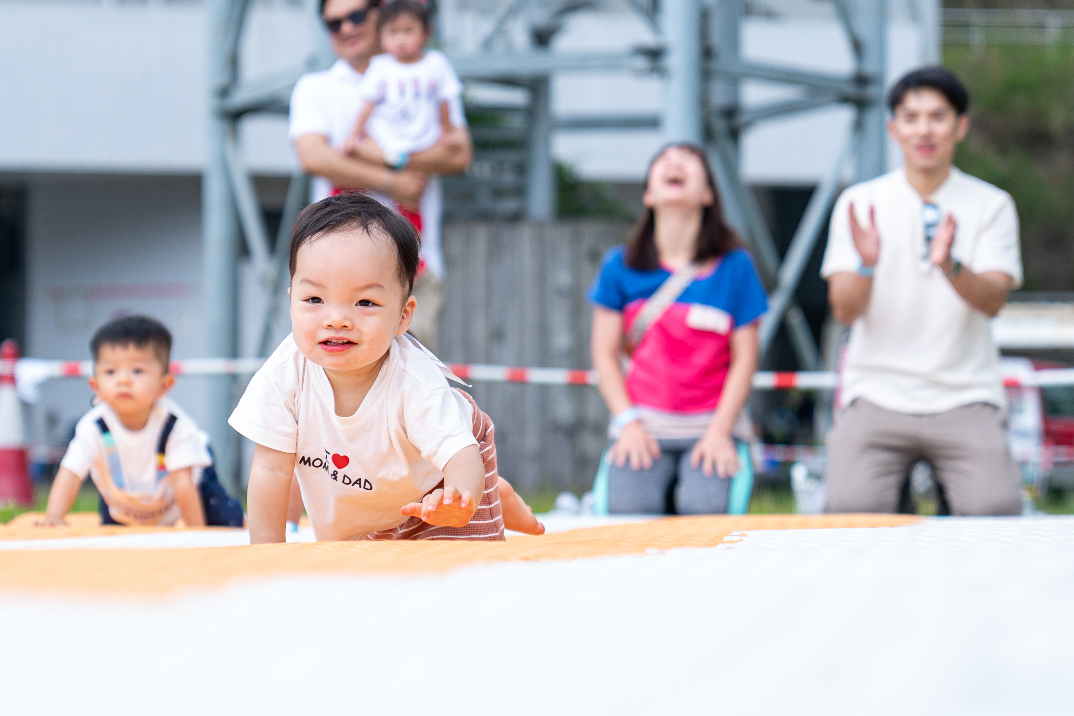 | - Distance: 15m  - Baby must complete within 2 minutes. Those who cannot finish will be disqualified.  - Only crawling is allowed. Walking or running will result in disqualification.  - Shoes are not allowed on the track.  - One parent may stand in front of the baby to guide them but must maintain a certain distance. Direct contact is not allowed.  - Parents may bring one small item to attract the baby, however, opened food and drinks are not allowed.
Baby Carriers  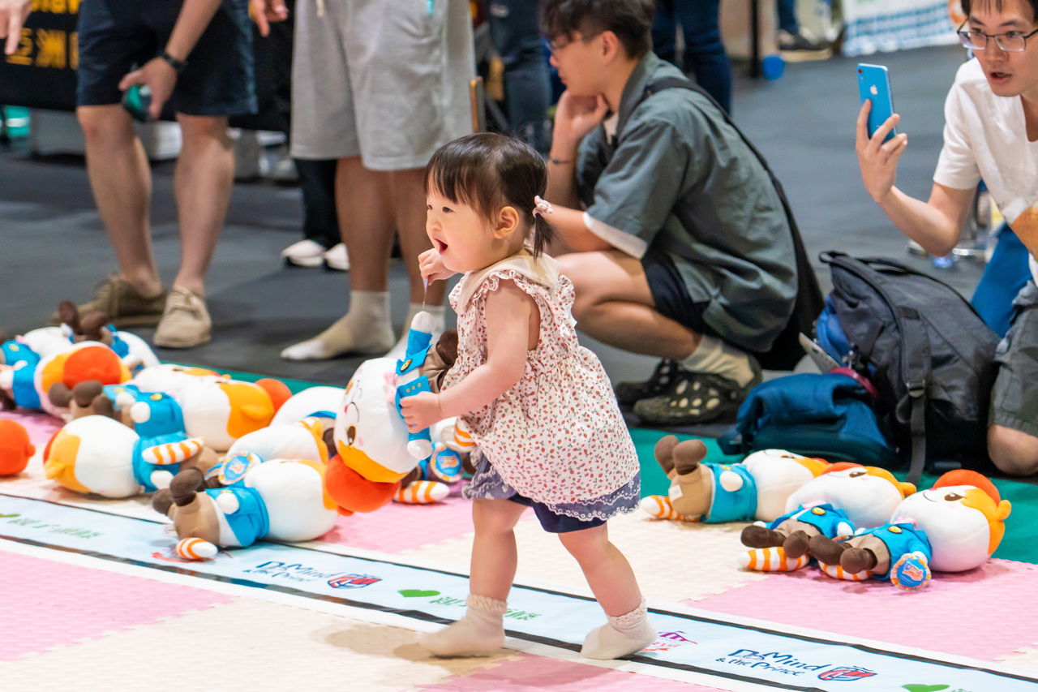 | - The baby must move as many items as possible from the end point to the starting point within 2 minutes.  - Shoes are not allowed on the track.  - Parents are not allowed to stay on the track.
Javelin Throw  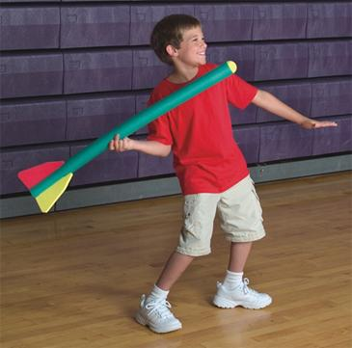 | - Each child is allowed 3 attempts (throws). The longest valid throw will be recorded as the final score.  - Participants may take a run-up within the 10-meter area and must release the javelin before the foul line. If a participant’s foot crosses the foul line, the throw will be considered invalid, and the javelin will not be measured.  - The javelin must land within the marked landing sector. The distance will be measured from the point where the javelin first lands.
Ball Dart  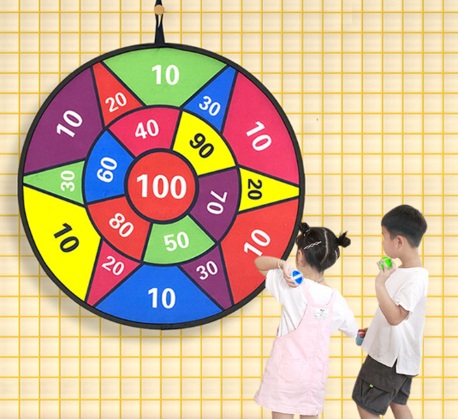 | - Each child is allowed 3 attempts (throws). The total points from all successful throws will be counted.  - Participants must stand behind the throwing line.  - Throw the soft sticky ball toward the dartboard. Only throws that stick to the board will be counted.  - If the ball lands on a line between two scoring zones, the lower score will be awarded.  - In the event of a tie at the maximum score (300 points), the participant with the shortest total time to complete all three throws will be declared the winner. Time will be recorded from the first throw to the last, as noted by an event staff.
Parachute Run   | - Distance: 30m & 50m  - Child must start behind the starting line with the parachute securely attached.  - The winner is the participant who crosses the finish line first after completing the full distance with the parachute.
Individual Run   | - Distance: 100m  - Child must start behind the starting line.  - The winner is the participant who crosses the finish line first after completing the full distance.
4-legged Race   | - Distance: 50m  - Each team consists of 3 family members who must complete the race together.  - Each team must line up with the child in the middle and one adult on each side for balance and safety.  - A strap will be used to tie each of the child’s legs to the leg of the adult beside them.  - Adults are not allowed to lift the child; the child’s feet must remain on the ground at all times.  - The straps must be securely fastened before moving. If they become loose, the team must stop and retie them before continuing. (Definition: The tied legs must remain in contact with each other at the ankle, calf, or knee.)
Ball-Rolling Race  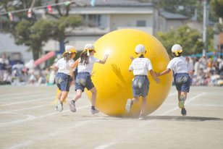 | - Distance: 100m  - Ball size: 1.2 meters in diameter  - Each team may use two lanes.  - A team of 3 family members must work together to roll the ball to the finish line.  - Hands must remain in contact with the ball at all times. Kicking the ball is not allowed.
1+1 Parachute Relay   | - Distance: 200m  - Each team consists of 1 adult and 1 child.  - The adult will complete the first 100 meters with the parachute securely attached.  - The child will then complete the second 100 meters with the parachute properly secured.  - The parachute must remain fully open and attached throughout each runner’s race.  - The winner is the team that completes the full 200 meters in the shortest time.

- Awards and certificates will be presented to participants. The details are as follows:

Entitled to Medal | - Individual Competition (by Age Group, mixed gender):  Top 3 place in each age group will receive a medal
Entitled to Trophy (All Round) | - Individual Competition All Round Award (by Age Group, by Gender):  Champion in each age group (2–14) for both boys and girls receive a trophy
Winners Certificates | - Certificates for winners will be issued after the event
Certificates of Participation | - Certificates of Participation will be issued to all participants who complete any competitions. All certificates will be issued after the event.

Part C: Drawing Competition (Online)
Artwork submission deadline: 12:00 noon Monday, 4 May 2026
Registration and Submission link: https://forms.gle/pMjYvDdHPCU5vsi19
- The Drawing Competition will be held virtually where participants will submit their artwork online for voting.

- Age groups for Drawing Competition are as follows:
Age group
Aged 2
Aged 3
Aged 4
Aged 5
Aged 6
Aged 7
Aged 8
Aged 10
Aged 11
Aged 12
Aged 13
Aged 14

- Theme: Dream Big with Love
- The original drawing must be on A4-sized paper. There are no restrictions on drawing style, colouring method, or materials used. Participants may include titles or captions in their drawings.
- Participants must scan their drawings for submission. The scanned image must have a resolution of no less than 200 dpi and should be within 50MB in JEPG/PNG/PDF file.
- Participants are required to have their parents (who is a member) declare the originality and authenticity of the artwork during submission.
- The scanned drawing and declaration must be submitted via the online form on or before the set deadline. Late submissions will not be accepted.
- Only 1 drawing may be submitted per participant.
- Participants may resubmit their drawings at any time before the deadline. Please note that only the last submission received on or before the deadline will be considered final. All previous submissions will be overwritten and will not be considered.
- Results of Drawing Competition will be determined by voting of a judging panel.
- Intellectual property of all artworks will vest in the Law Society.
Part D: Talent Show (Online)
Video submission deadline: 12:00 noon Monday, 4 May 2026
Registration and Submission link: https://forms.gle/iu87y7wY25dcRyAj7

- The Talent Show will be held virtually where participants will submit videos of their performance online for voting.

- Age groups for Talent Show are as follows:

Age group
Aged 2
Aged 3
Aged 4
Aged 5
Aged 6
Aged 7
Aged 8
Aged 9
Aged 10
Aged 11
Aged 12
Aged 13
Aged 14

- Performance categories
  - Music-related (singing, playing musical instruments)
  - Sports-related (dance, martial arts, gymnastics)

- Participants must submit a video recording of their performance. The video must not exceed 3 minutes in length. Videos should be submitted via the online form on or before the set deadline. Late submissions will NOT be entertained.
- Only one video may be submitted per participant.
- Participants may resubmit their videos at any time before the deadline. Please note that only the last submission received on or before the deadline will be considered final. All previous submissions will be overwritten and will not be considered.
- Results of Talent Show will be determined by voting of a judging panel.
- A trophy and a certificate will be awarded to the top 3 participants in each age group who receive the highest number of likes. In the result of a tie, the winner will be determined by a judging panel.
- Intellectual property of all artworks will vest in the Law Society.
Part E: Registration

Registration and payment deadline: 12:00 noon Monday, 4 May 2026
Registration link: https://forms.gle/sxSDdspfwavCyamh8

Members are required to join the Recreation and Sports Programme 2026 (the "Programme") before the Fun Day for eligibility to enrol their child(ren)/ grandchild(ren) and/or family members in all the events. For those members who have not joined the Programme, please sign up and settle the enrolment fee by completing the online registration form (Member Zone login required).

Please complete the two-step registration i.e. (1) payment of entrance fee, and (2) submission of personal particulars and events enrolment, on or before 12:00 noon Monday, 4 May 2026. Registration and payment via other means will NOT be entertained.

STEP 1: Payment of entrance fee

- Please complete payment of relevant entrance fee via The Law Society’s website (Member's zone login is required).

- Please refer to the table below for the corresponding application link for enrolment via the System.

No. of child(ren) | Event to be added to the shopping cart | Application link
1 | RSC-16th Members and Family Fun Day (sign up for one child) | 20260400002
2 | RSC-16th Members and Family Fun Day (sign up for two children) | 20260400003
3 | RSC-16th Members and Family Fun Day (sign up for three children) | 20260400004
4 or above | Please contact RnS@hklawsoc.org.hk for assistance.

- A system-generated email will be sent to you upon successful payment.

STEP 2: Submission of personal particulars and events enrolment

- Upon completion of payment via the System, please submit the personal particulars of your child(ren)/grand-child(ren) and indicate the event(s) that he/she (they) would like to sign up for via this link. Please submit ONE form per family.

Important notes regarding registration confirmation and event communication

- Enrolment will only be completed upon completion of the two steps above i.e. (1) full payment of the entrance fee AND (2) submission of personal particulars and event enrolment by the stated deadline.
- Upon successful registration, you will receive an email confirmation, which is the only official confirmation of your enrolment, from the Law Society. You will be required to show the email confirmation, to the organiser at the event, so please be reminded to check your email (including spam mails/junk mailbox) for the confirmation. If you do not receive the email confirmation by Friday, 8 May 2026, please contact us on RnS@hklawsoc.org.hk, otherwise you may treat your enrolment as UNSUCCESSFUL.

- The organiser will provide updates of the event from time to time and these updates will be made available via Law Society weekly Circulars, social media platforms and/or emails. Please be reminded to check your emails (the email address you provided in the online enrolment form) to ensure you receive the updates.

