2 October 2025

RUNNING TEAM
2025 Coaching Sessions for Runners
October to December 2025
(Repeat Circular)

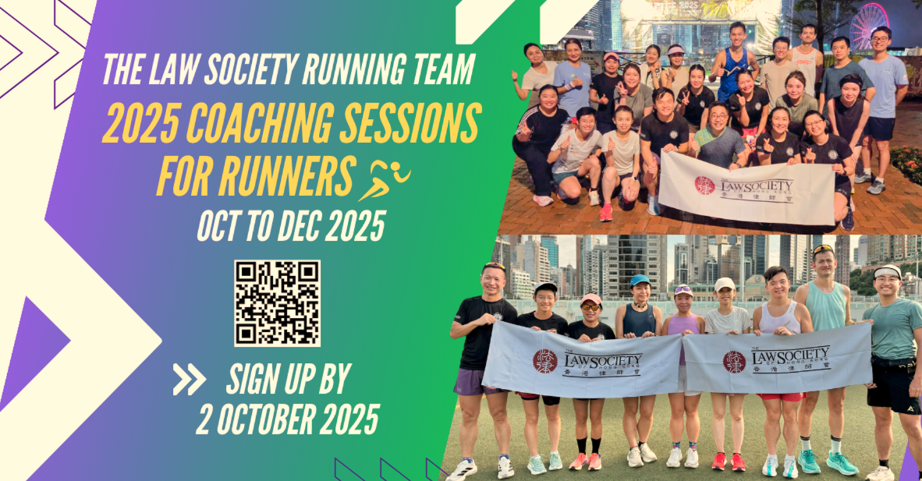

- The Law Society Running Team will organise a new series of professional coaching sessions from October to December 2025 (click here for video). The Team will once again invite Ms Sophia Lai, Hong Kong elite runner, (click here for profile) as the coach of this new coaching series on Mondays and Saturdays. Members with minimal experiences, or even new to running, are welcome.

- Details of the coaching sessions are as follows:

 | (A) Monday night classes:  13 October to 29 December 2025  (12 sessions) | (B) Saturday morning long runs:  4 October to 20 December 2025  (5 sessions)
Dates: | - October: 13, 20 & 27  - November: 3, 10, 17 & 24  - December: 1, 8, 15, 22 & 29 | - October: 4  - November: 1 & 22  - December: 6 & 20
Time: | 7:30 pm to 9:00 pm | 7:00 am to 10:00 am
Venue: | Central Promenade | Happy Valley Sportsground
Minimum Class Size: | 15 pax | 15 pax
Fees & Registration Options: | A + B (17 sessions): HK$1,300
Fees & Registration Options: | (A) only (12 sessions): HK$1,000 | (B) only (5 sessions): HK$400
Remarks: | - Participants are required to join the Recreation and Sports Programme 2025 and the Law Society Running Team. If you have not joined the Programme yet, please sign up according to the enrolment and payment instructions.  - ALL fees are non-refundable and non-transferable and cannot be paid on a pro-rata basis.  - The Law Society reserves the right to alter any arrangements including cancelling the classes if it is under-subscribed or reschedule any session due to inclement weather conditions.

- For those members who are interested in joining the coaching sessions, please register via the online form and complete payment by Thursday, 2 October 2025. For details, please refer to the online form.

- Personal Information Collection Statement

The personal data collected in the process of registration (the “data”) will be used by the Law Society (the “Organiser”) for registration of the 2025 Coaching Sessions for Runners (“the classes”), making logistical arrangements, and other related purposes. The data may be provided to such persons within the Law Society whose proper business is to process your registration of the classes, and may also be provided to other persons who may facilitate the Organiser to carry out the purposes mentioned above. Any data that is provided to anyone outside of the Organiser will be restricted to what is necessary to achieve any intended purposes. You have the right to request access to and correction of the data. Any such request should be addressed to the Secretary General, The Law Society of Hong Kong, 3/F, Wing On House, 71 Des Voeux Road Central, Hong Kong. The Privacy Policy Statement of the Law Society is available on its website at www.hklawsoc.org.hk.

- Statement on Use of Event Photos and/or Videos

The classes may be photographed, videotaped, screen captured and/or video recorded for the Law Society’s records and/or promotion of future events. By participating in this event, you and any accompanying person(s) (where applicable) consent to be photographed, videotaped, screen captured and/or video recorded, and permit the Law Society to use such image(s) for internal records, educational and marketing purposes, including promotional materials such as, but not limited to, the Law Society’s websites, social media platforms and publications. In the case where your minor child(ren) take(s) part in the classes, you give permission to the Law Society to use your child/children’s images for the aforesaid purposes.

- For enquiries related to the class(es), please contact the Running Team with details below:
- Mr Sonny Lam, Running Team Captain: 6218 2212 or cslsonny@yahoo.com; or
- Ms Catherine Lau, Running Team Convenor: 6107 0230 or catherinelsf@gmail.com; or
- Mr Danis Wong, Running Team Convenor: 9088 2813 or wongsorlam@gmail.com

