25 September 2025

RUNNING TEAM
The Law Society Running Team's Time Trial 2025 (Mini Race)
18 October 2025
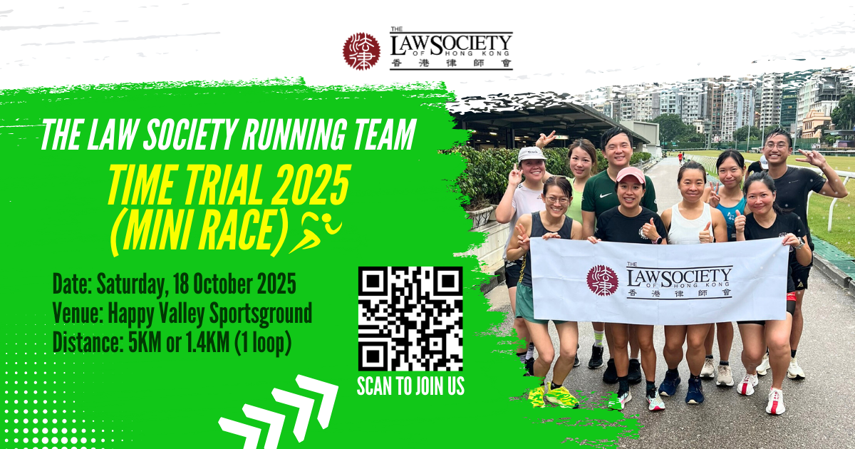

- The Law Society Running Team will host the Time Trial 2025 (Mini Race) on 18 October 2025 at Happy Valley Sportsground. The event aims to unite runners of all levels, strengthen team spirit, and build camaraderie among members, while celebrating recent RSCP SCM Award achievements and preparing for future races.

- Details are as follows:

 | Time Trial 2025 (Mini Race)
Dates: | 18 October 2025
Time: | 7:15 AM | Registration/Race Bib pick-up
Time: | 7:30 AM | Warm up + Drills
Time: | 8:00 AM | 5000m Time Trial begins
Time: | 9:00 AM | 1400m Time Trial begins
Time: | 9:40 AM | Award ceremony & refreshments
Venue: | Happy Valley Sportsground
Awards: | (a) Medals for top 3 runners in each distance/age group/category. (b) Trophies for overall winners in each distance/category
Remarks: | - Participants are required to join the Recreation and Sports Programme 2025 and the Law Society Running Team. If you have not joined the Programme yet, please sign up according to the enrolment and payment instructions.  - The Running Team reserves the right to update any arrangements including re-scheduling in case of inclement weather conditions (amber rainstorm or T3 signal or above being hoisted after 5am on the event date) or other reasons; and/or cancelling the event due to under subscription.

- For those members who are interested in joining the event, please register via the online form by Friday, 10 October 2025. For details, please refer to the online form.

- Personal Information Collection Statement

The personal data collected in the process of registration (the “data”) will be used by the Law Society (the “Organiser”) for registration of The Law Society Running Team's Time Trial 2025 (Mini Race), making logistical arrangements, and other related purposes. The data may be provided to such persons within the Law Society whose proper business is to process your registration of the event, and may also be provided to other persons who may facilitate the Organiser to carry out the purposes mentioned above. Any data that is provided to anyone outside of the Organiser will be restricted to what is necessary to achieve any intended purposes. You have the right to request access to and correction of the data. Any such request should be addressed to the Secretary General, The Law Society of Hong Kong, 3/F, Wing On House, 71 Des Voeux Road Central, Hong Kong. The Privacy Policy Statement of the Law Society is available on its website at www.hklawsoc.org.hk.

- Statement on Use of Event Photos and/or Videos

The Mini Race may be photographed, videotaped, screen captured and/or video recorded for the Law Society’s records and/or promotion of future events. By participating in this event, you and any accompanying person(s) (where applicable) consent to be photographed, videotaped, screen captured and/or video recorded, and permit the Law Society to use such image(s) for internal records, educational and marketing purposes, including promotional materials such as, but not limited to, the Law Society’s websites, social media platforms and publications. In the case where your minor child(ren) take(s) part in the event, you give permission to the Law Society to use your child/children’s images for the aforesaid purposes.

- For enquiries related to the class(es), please contact the Running Team with details below:
- Mr Sonny Lam, Running Team Captain: 6218 2212 or cslsonny@yahoo.com; or
- Ms Catherine Lau, Running Team Convenor: 6107 0230 or catherinelsf@gmail.com; or
- Mr Danis Wong, Running Team Convenor: 9088 2813 or wongsorlam@gmail.com

