Annexure 1

Legal Course on the Construction of
Foreign-Related Rule of Law of Hong Kong
25 – 30 April 2025

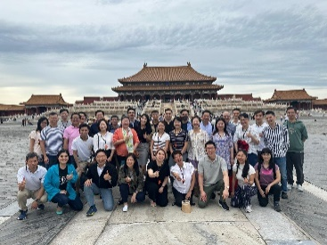
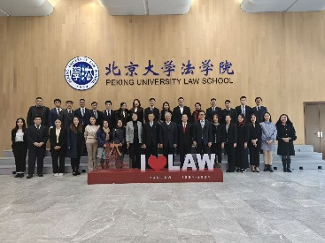
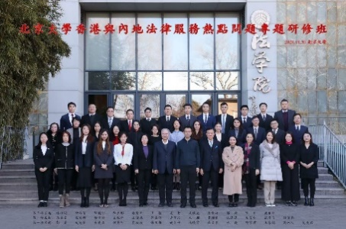
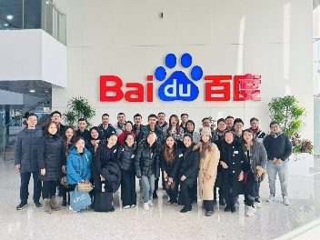

The Department of Law of the Liaison Office of the Central People’s Government in the Hong Kong Special Administrative Region (“LOCPG”) will organise a legal course at the Peking University (“PKU”) under the title “Topics relating to the Construction of Foreign-related Rule of Law of Hong Kong” (香港涉外法治建設專題研修班) from 25 to 30 April 2025. Lecturers of the course include experts and professors from PKU. Participants will also visit high-tech enterprises such as Xiaomi, historical exhibition halls and other venues. The course is free of charge with complimentary accommodation. All participants are required to pay for their own travelling expenses. The programme is open to all members of the Hong Kong legal profession. The number of places is limited. Legal professionals in Hong Kong are cordially invited to sign up as soon as possible.

Dates
25 April (Friday) to 30 April 2025 (Wednesday)

Venue
Lectures: PKU
Accommodation: Building 9, Zhongguan Xinyuan, PKU

Itinerary
- 25 April 2025 (Friday)
Course attendees arrive in Beijing and check into Zhongguan Xinyuan, PKU

- 26 April (Saturday) to 30 April 2025 (Wednesday)
Lectures and visits (the course details and the enterprises to be visited are to be determined)

- 30 April 2025 (Wednesday)
Return to Hong Kong in the afternoon

Others
- In accordance with the regulations of PKU for universal management, course attendees’ records will be created and filed with PKU after completion of the course.

- Upon completion of the course and passing of the assessment, PKU will issue a completion certificate to the course attendees.

- The number of places is limited. Those who are interested in participating should click here to register before 14 March 2025 (Friday). The final list of participants will be determined and notified by the Legal Department of the LOCPG . Legal professionals who have not participated in the training course before will be given priority.

- The Department of Law of the LOCPG will hold training courses on national affairs at the National Academy of Governance from 18 May to 22 May 2025, and at the National Judges College at the end of June 2025. Interested parties please stay tuned for the registration notice(s) later.

香港涉外法治建設專題研修班
2025年4月25日至30日

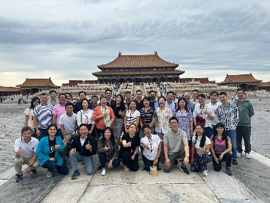
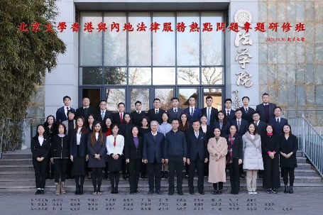

中央人民政府駐香港特別行政區聯絡辦公室（中聯辦）法律部將於4月25日至30日於北京大學舉辦「香港涉外法治建設專題研修班」，邀請北京大學知名專家教授授課，並參訪小米等高新技術企業、歷史展覽館等場館。所有學員只需自購來回機票，其他費用全免。名額有限，報滿即止，歡迎香港法律界人士踴躍報名。

時間
2025年4月25日（週五）至30日（週三）

地點
上課：北京大學
住宿：北京大學中關新園 9 號樓

行程
- 2025年4月25日（週五）︰學員自行赴京，入住北京大學中關新園
- 2025年4月26日至4月30日（週六至週三）︰上課及參訪（課程及參訪企業待定）
- 2025年4月30日（週三）︰下午返港

其他
- 按北京大學制度統一管理，建立學員檔案，結業後在該校存檔。

- 學員完成全部課程學習經考核合格，統一頒發北京大學結業證書。

- 名額有限，報滿即止。有意參加者請於3月14日前點擊此處報名，最終參班人員由中聯辦法律部決定並通知，優先考慮此前未參加過研修班的法律界人士。

- 中聯辦法律部將於2025年5月18 – 22日、2025年6月底在分別在國家行政學院、國家法官學院舉辦國情研修班。歡迎感興趣人士後續關注報名通知。

