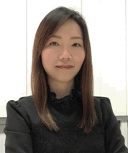
FANCL資深營養師Toby Leung
FANCL Senior Nutritionist Toby Leung
- 香港中文大學食品營養與科技碩士
Master of Science in Nutrition, Food Science and Technology
- 擔任營養補充品專業培訓導師逾10年
Solid 10+ years of health supplement training experiences
- 曾於香港專業教育學院教授營養學高級文憑課程
Performed teaching duties for higher diploma courses in tertiary education institute
- 超過10年編寫營養餐單經驗，協助不同人士管理健康及體重
Provided individual nutritional consultation and meal planning services over 10 years
- 曾撰寫報章營養專欄及主講過百場健康講座
Organized over 100 health talks, public seminars, cooking programs, and wrote nutrition articles for local popular media

